**Lab 12**

1. **[3] Calculate the cost of the three strategies listed below if the *Staff* relation has 10000 tuples, *Branch* has 500 tuples, there are 500 Managers (one for each branch) and there are 10 London branches.**

**Three equivalent RA queries are:**

1. (position='Manager')  (city='London')  (Staff.branchNo=Branch.branchNo) (Staff  X Branch)

Ans:-

* 1. Read staff = 10000
  2. Read branch = 500
  3. X write = 10000*500
  4. Read = 10000*500

=10000+500+2*(10000*500)

=100010500

1. (position='Manager')  (city='London') (Staff  ⋈ Staff.branchNo=Branch.branchNo Branch)

Ans:-

* 1. Read staff = 10000
  2. Read branch = 500
  3. ⋈  write = 10000
  4. Read = 10000

=2*10000+(10000+500)

=30500

1. ((position='Manager') (Staff))  ⋈ Staff.branchNo=Branch.branchNo ((city='London') (Branch))

Ans:-

* 1. Read staff = 10000
  2. Write 500
  3. Read branch = 500
  4. Write = 10
  5. Read = 500+10

=10000+500+2*(500+10)

=11520

1. **[3] Using the Hotel schema given below, determine whether the following queries are syntactically and/or semantically correct.**

**Hotel (hotelNo, hotelName, city)**

**Room (roomNo, hotelNo, type, price)**

**Booking (hotelNo,  guestNo, dateFrom, dateTo, roomNo)**

**Guest (guestNo, guestName, guestAddress)**

     (a)  SELECT r.type, r.price

            FROM Room r, Hotel h

            WHERE r.hotel_number = h.hotel_number AND

            h.hotel_name = ‘Grosvenor Hotel’ AND

            r.type > 100;

Ans:- -Not semantically correct

-hotel_number and hotel_name is not correct and should be hotelNo and hotelName.

- type is not a numeric value.

     (b)  SELECT g.guestNo, g.name  
  FROM Hotel h, Booking b, Guest g

  WHERE h.hotelNo = b.hotelNo AND h.hName = ‘Grosvenor Hotel’;

 Ans:- -Not semantically correct

- h.hname is not correct and should be hotelName.

- g.name is not available in the table.

     (c)   SELECT r.roomNo, h.hotelNo  
  FROM Hotel h, Booking b, Room r  
  WHERE h.hotelNo = b.hotelNo AND h.hotelNo = ‘H21’ AND  
  b.roomNo = r.roomNo AND type = ‘S’ AND b.hotelNo = ‘H22’;

Ans:- -Not semantically correct

- hotelNo should be a numeric value.

- room is not related to a

1. **[4] Using the same Hotel schema, draw a relational algebra tree for each of the following queries and use the heuristic rules given in Section 23.3.2  to transform the queries into a more efficient form:**

(a)   SELECT r.roomNo, r.type, r.price  
       FROM Room r, Booking b, Hotel h  
       WHERE r.roomNo = b.roomNo AND b.hotelNo = h.hotelNo AND   
                      h.hotelName = ‘Grosvenor Hotel’ AND r.price > 100;

Ans:- 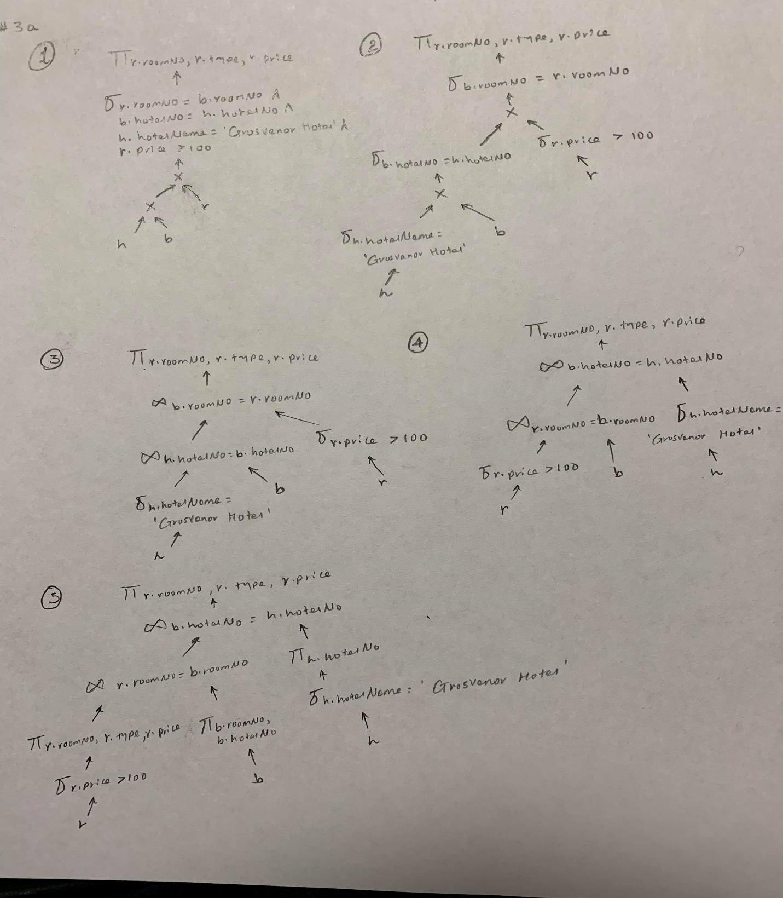

(b)  SELECT g.guestNo, g.guestName  
      FROM Room r, Hotel h, Booking b, Guest g  
      WHERE h.hotelNo = b.hotelNo AND g.guestNo = b.guestNo AND  
                       h.hotelNo = r.hotelNo AND h.hotelName = ‘Grosvenor Hotel’ AND  
                       dateFrom >= ‘1-Jan-01’ AND dateTo <= ‘31-Dec-01’;

Ans:-

